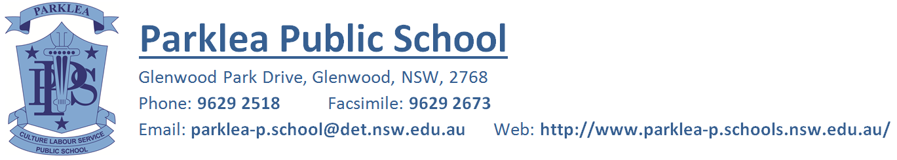

Friday 3rd April, 2020
Learning Pack Collection
Dear Parents/Carers,
We would like to take this opportunity to thank all parents/carers for your continued support over the last two weeks with assisting your child/children in learning from home. We at Parklea understand that this has brought on many challenges for families and wish to congratulate the students on the work they have been completing and submitting each day.
In order for teachers to be able to prepare work for the beginning of Term 2 we are requesting that all families return their child/children’s learning pack to school on Monday 6th and Tuesday 7th April 2020. A collection table with grade tubs will be set up at the front of the school from 8:30am to 3:15pm for all families to come and place their child/children’s work in. We understand that some families have had difficulties in completing all set learning tasks. Please be reassured that there is no pressure for students and families to complete all set work during this uncertain time.
Due to this early collection, there will be no additional work uploaded by the teachers via Google Classroom after Tuesday and for the remainder of the term. In order for adequate planning and preparation to take place for Term 2 we require all families to complete the Parklea Public School Learning from Home survey which was released earlier this week.

Kind Regards,

Katarina Jurcevic Fiona Gracie
Rel. Assistant Principal Principal

